Que 1) Plot a histogram,

10, 13, 18, 22, 27, 32, 38, 40, 45, 51, 56, 57, 88, 90, 92, 94, 99

Ans 1)

x = c(10, 13, 18, 22, 27, 32, 38, 40, 45, 51, 56, 57, 88, 90, 92, 94, 99)

hist(x)

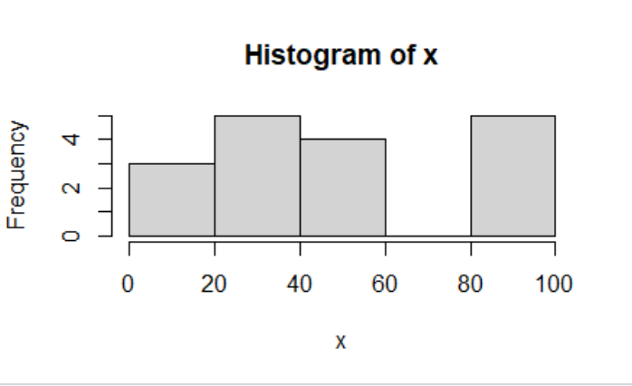

Que 2) In a quant test of the CAT Exam, the population standard deviation is known to be 100. A sample of 25 tests taken has a mean of 520. Construct an 80% CI about the mean.

Ans 2)

Standard Deviation = 100

Mean = 520

No of observation = 25

Significance Level = 1 - Confidence Interval (1 - 0.8 = 0.2)

Point Estimate +/- Margin of Error

X +/- Z L/2 (SD/ ROOT N)

Lower Fence = 520 – 1.29 \* 20 = 520 – 25.8 = 494.2

Upper Fence = 520 + 1.29\*20 = 520 +25.8 = 545.8

Que 3) A car believes that the percentage of citizens in city ABC that owns a vehicle is 60% or less. A sales manager disagrees with this. He conducted a hypothesis testing surveying 250 residents & found that 170 residents responded yes to owning a vehicle.

1. State the null & alternate hypothesis.
2. At a 10% significance level, is there enough evidence to support the idea that vehicle owner in ABC city is 60% or less.

Ans 3)

Null Hypothesis : Ho : Po = 60%

H1 : P1 <> 60%

N = 250

X = 170

P = X/N = 170/250 = 0.68

Significance Level = 0.1

Upper Fence = 1.29

Lower Fence = -1.29

Z Test = 0.68 – 0.60/SQRT(0.6\*0.4/250) =2.58

The calculated upper and lower fence is below

Upper Fence = 2.58 and Lower Fence = -2.58

1 – 0.9956 = 0.0044

The calculated p values is 0.0044 and it is lower than 0.10 of the significance level hence we reject null hypothesis.

Que 4) What is the value of the 99 percentile?

Ans 4)

2,2,3,4,5,5,5,6,7,8,8,8,8,8,9,9,10,11,11,12

Value = (Percentile/100)\*n

Value = (99/100)\*20

Value = 19.8 (Index)

The value of 99 percentile is 12

Que 5) In left & right-skewed data, what is the relationship between mean, median & mode?

Draw the graph to represent the same.

Ans 5)

In case of a negatively skewed frequency distribution, the mean is always lesser than median and the median is always lesser than the mode.

